**JavaScript Executor :**

JavaScriptExecutor is an Interface

It will allow us to execute JavaScript methods through Selenium webdriver

In some places selenium can't be work at that time we use JavaScript

to interact that Webelement.

Syntax :

JavaScriptExecutor js= (JavaScriptExecutor) driver;

js.executeScript("arguments[0].scrollIntoView();", WebElementName)

js.executeScript("window.scrollBy(0,range);")

eg :

js.executeScript("window.scrollBy(0, 1000);")---> Scroll down

js.executeScript("window.scrollBy(0, -3000);") ----> Scroll up

js.executeScript("arguments[0].click();", webelementname ) ---> click

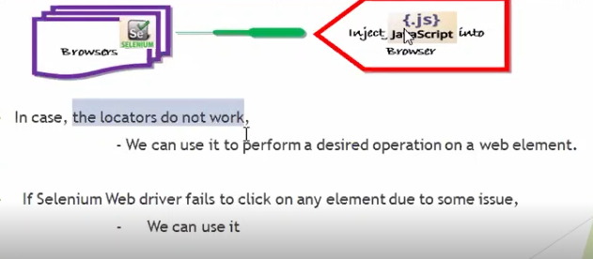

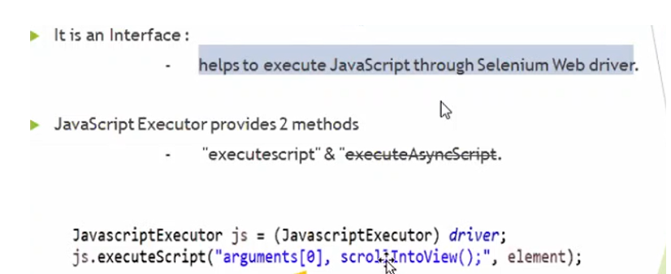

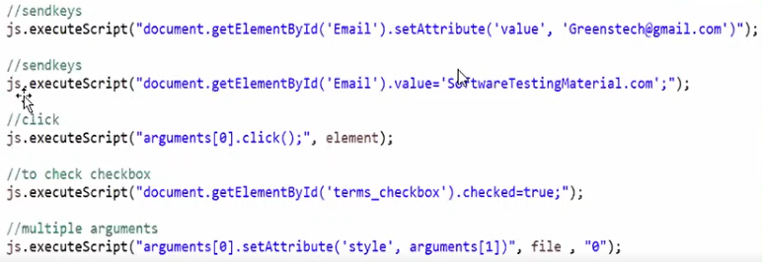

Amazon Task: Action, Robot, JavaScript Executor, Screenshot